**Workshop – Black Box Testing**

**Question1: Boundary Value Analysis**

Assume, we have to test a field which accepts Age 18 – 56



**How many test cases should be checked here?**

**Your answer: There should be checked 6 test cases.**

|  |  |
| --- | --- |
| **Test Scenario Description** | **Expected Outcome** |
| **Boundary value = 17** | **System should Not accept** |
| **Boundary value = 18** | **System should accept** |
| **Boundary value = 19** | **System should accept** |
| **Boundary value = 55** | **System should accept** |
| **Boundary value = 56** | **System should accept** |
| **Boundary value = 57** | **System should Not accept** |

**Question 2: Equivalence partitioning**

In an Examination, a candidate has to score a minimum of 24 marks in order to clear the exam. The maximum that he can score is 40 marks.  Identify the Valid Equivalence values if the student clears the exam. Please draw also valid and invalid partitions.

a)    22,23,26  
b)    21,39,40  
***c)    29,30,31***d)    0,15,22

**Your answer:**

|  |  |  |
| --- | --- | --- |
| **Invalid** | **Valid** | **Invalid** |
| **0 - 23**  **Partition 1** | **24-40**  **Partition 2** | **41 and more**  **Partition 3** |

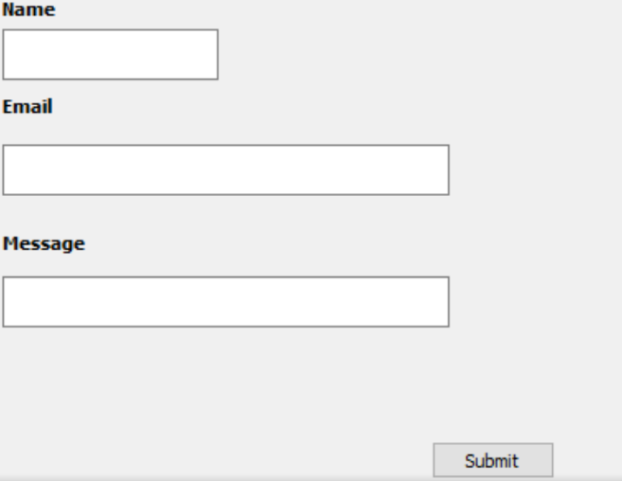**Question 3: Decision table**

**Submit button in Contact Form is**

**enabled when all the inputs are entered by the end user.**

**Your answer: Make decision table with T/F**

|  |  |  |  |  |  |  |  |  |
| --- | --- | --- | --- | --- | --- | --- | --- | --- |
|  | **Test Case1** | **Test Case2** | **Test Case3** | **Test Case4** | **Test Case5** | **Test Case6** | **Test Case7** | **Test Case8** |
| **Name (T/F)** | **T** | **T** | **T** | **F** | **T** | **F** | **F** | **F** |
| **Email (T/F)** | **T** | **T** | **F** | **T** | **F** | **F** | **T** | **F** |
| **Message(T/F)** | **T** | **F** | **T** | **T** | **F** | **T** | **F** | **F** |
| **Submit (H/E)** | **H** | **E** | **E** | **E** | **E** | **E** | **E** | **E** |

**Question 4: State Transition table**

Login page of an application which locks the user name after three wrong attempts of password.

**Your answers**

1. **Draw State Transition Diagram**

Incorrect Pin **Incorrect Pin**

Incorrect Pin

**Incorrect Pin**

Correct Pin

1. **Make State Transition table**

|  |  |  |  |
| --- | --- | --- | --- |
| **State** | **Login** | **Correct Password** | **Incorrect Password** |
| **S1 (First Try)** | If in S1 You enter the correct pin, you go to S4.  If in S1 You enter the incorrect pin, You go to S2. | S4 | S2 |
| **S2 (Second Try)** | If in S2 You enter the correct pin,you go to S4.  If in S2 You enter the incorrect pin, You go to S3. | S4 | S3 |
| **S3 (Third Try)** | If in S3 You enter the correct pin,you go to S4.  If in S3 You enter the incorrect pin, You go to S5. | S4 | S5 |
| **S4 (Access Granted)** | ---- | ---- | ---- |
| **S5 (System Blocked)** | ---- | ---- | ---- |